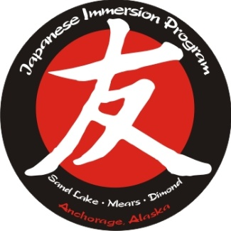

Tomo No Kai Board Meeting
February 22, 2023 Minutes

Call to order at 6:30PM – Attendees – Erin, Kourtney, Demi, Kay, Stephanie, Joanna, Kehle, Sara

Spring Art Auction – April 15th – looking at the Lakefront as a venue; Might approach Yamamoto Sensei to help with something on the high school level. Will have a wine wall, gift card punch, and dessert dash. Hayley volunteered to do the wine wall again. Trying to make sure we give the Chitose parents the opportunities to get their volunteer hours, but it is up to them to sign up and get those hours, or they will need to pay the extra $500. Erin is going to send out an email to class reps to start collecting items for the auction. Also need volunteers to help with art projects in the classrooms. Erin will send an email to class reps and one to Chitose parents.
Cherry Blossom Festival – April 28th – at Mears – Kehle will request the space – have to go through the PTSA to make the request. Gellert and Yamamoto have agreed to offer extra credit to high school students to help with booths. Chitose parents can earn some hours at this event, but any fundraising that they are helping with for the trip does not count for volunteer hours.
Board membership recruitment – General meeting in March – when we send out the reminder, we’ll do a plug for membership and then nominate and vote on board members at that general meeting. Board members get voted in at the general meeting, and then executive positions will be voted on at the April board meeting.
Budget update –
Budget is done; Erin passed out budget and profit and loss statement; Chitose inbound came in under budget – Kehle was able to get some discounts, and Dimond wound up paying for some of it, as well. We might want to look at increasing the budget for next year to account for any rise in prices.
Chitose Outbound is budgeted for $12K (what we pay for the administrators to go) – everything is going through the Chitose Wells Fargo account – we’re at 24 students. Trip is scheduled 5/26-6/10 and flights are mostly booked.
There was some discussion on the school board approval of moving 6th grade to Mears and what that will mean for future Chitose trips and Japanese classes/teachers going forward.
TNK is also paying for the Dimond student – intern activities.
There was some discussion around offering tutoring to all students and not just needs based because no one has taken advantage of the offering for the last several years. We could potentially offer a certain number of hours free and then after that, they charge the families. Teachers could put it in their newsletters and we can have the class reps send it out. Erin could field the requests through the TNK info email and send them to Haruki to arrange with the interns.
Might consider adding a TNK scholarship for high school students who want to do a study abroad program in Japan.
Intern update –
Haruki will be attending the April board meeting to talk more about the changes with the interns next year with ISSECS being gone. Haruki is doing a lot more of the work and coordination of interns these days. If Haruki moves to Mears, might need to pass that on to a different teacher so that it stays at Sand Lake.
Haruki is having a town hall with various universities – maybe we could look for student ambassadors that are recommended by teachers to join in on these town halls to help answer questions. Current interns might also be able to help.

