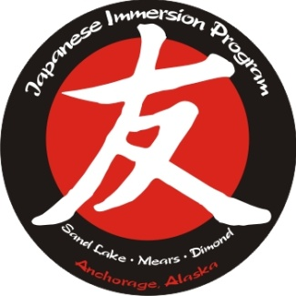

Tomo No Kai General Meeting
September 14, 2022 Minutes

Call to order at 6:00 PM

Budget Update – Budget isn’t finalized yet for this year because there are still some things outstanding from last year. Erin went over 3 main money raising efforts – TNK membership and donations, The Fall Family Dinner, and the Spring Art Auction. Usually the Fall dinner will bring in anywhere from $5-10K each year. Erin reviewed the Japan trips and how TNK funds these trips for the administrators and how that is a big part of our budget. Intern expenses are also a big part of the budget. Plan to have a budget that is finalized and voted on by the board at the next general meeting. Unsure what the status is of a potential Mears trip this summer. The TNK board will be scheduling a meeting with Mr. Backman and Ms. Chambers.

Fall Family Dinner – October 8th, from 6-8, and doors will open at 5:45. There will be meals to purchase – three different menu items – Katsu chicken, teriyaki beef, and veggie Udon noodles – each dish comes with lots of sides, too – dumplings, sushi rolls, tempura, and rice. QR code below to order meals. We will have Tons of Fun bouncy houses, a cupcake walk, Taiko performances, intern introductions, and possibly songs sung by different classes. We will also have a silent auction and make baskets with themes for each class. We will also be using the Black Cat Café coffee shop to make drinks during the event. We do need volunteers to help with this event. There is a QR code below to sign up to help volunteer for various tasks. We will also have TNK merchandise for sale.

ASD Budget Awareness – ASD is looking at their budget, and part of their conversations are around cutting immersion programs to help balance the budget. We would encourage our members to reach out to legislators to let them know how much we need to continue having the immersion programs. Per Mr. Thompson, was in a meeting about this just today – at the “rumor and hearsay” phase. Pretty much everything is on the table so there isn’t a whole lot of weight to the rumors at this point. As we move through the year, more information will start to solidify. There will eventually be a formal announcement of what will be cut. We definitely need advocates, though.
Membership Drive – We get a lot of our money from memberships and donations. We will have a membership drive coming soon – families will see information coming from their class reps soon with information on how to become a member and give donations. There will be a competition among grades to see which grades get the highest membership numbers.
Intern Update – we have 7 interns – 5 at Sand Lake, 1 at Mears, and 1 at Dimond. We need more host families for the 2nd and 3rd sessions. ISEC organization may be closing up business. Mr. Kamimura is trying to see if he can find someone to take over. If that doesn’t work, he will try to work individually with some colleges to facilitate bringing interns over going forward. We do have some colleges that we have stronger relationships with. We might be able to develop relationships with 1-3 colleges.
We have the intern’s monthly hangouts so that families can sign up to take interns out to do fun things. The intern welcome Potluck is scheduled this Monday, the 19th, at 6:00 PM.
We are also looking for short term hosts for families who might be traveling over holiday breaks. If anyone has fun trips planned and has an extra seat or two and wants to take an intern along, that would be very appreciated, too. It is a great way to thank the interns for all that they do for our kids.

The Russian Immersion program is hosting a run, and anyone involved with Japanese immersion who registers will have $5 of their registration donated.

Fall Family Dinner Volunteer Sign-Ups:
Fall Family Dinner Meal Purchases:

